Manual

Contents

How To Run Papoy 2

Start Menu 3

Drawing Kit 6

Main Frame 8

Menu Bar 11

# How To Run Papoy

1. Double Click on ???.exe to run the program.

2. This program is compatible for all major operating systems but best compatible with Mac OS.

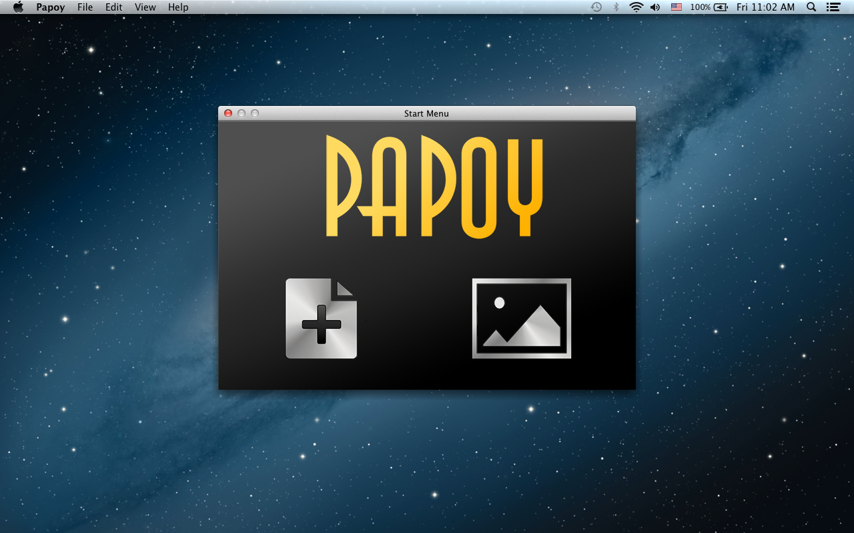

3. In Mac OS X 10.8.3 (Mountain Lion), this is how it should look like after launching Papoy. A pop up will be shown in centre of screen as the Start Menu. On the top left of the screen, the menu bar will contain 5 menu bar items.

1. Papoy
2. File
3. Edit
4. View
5. Help

# Start Menu

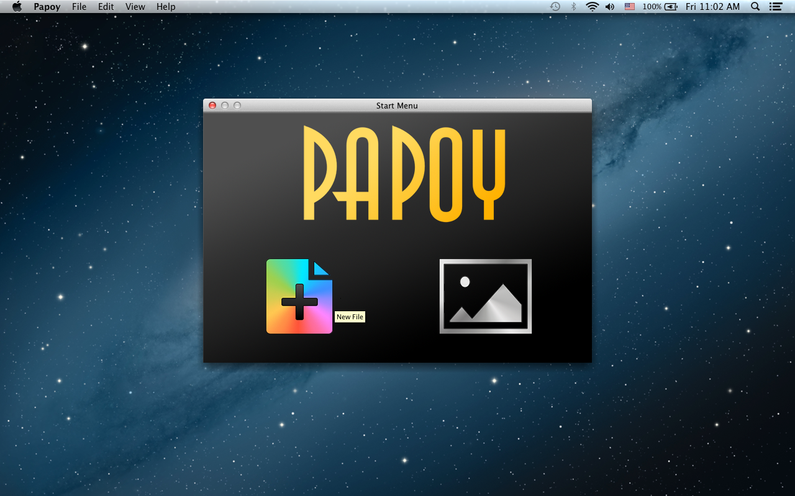

Creating New Svg

1. To create a new svg using Papoy, select on the New File icon which will be highlighted when you hover on it.

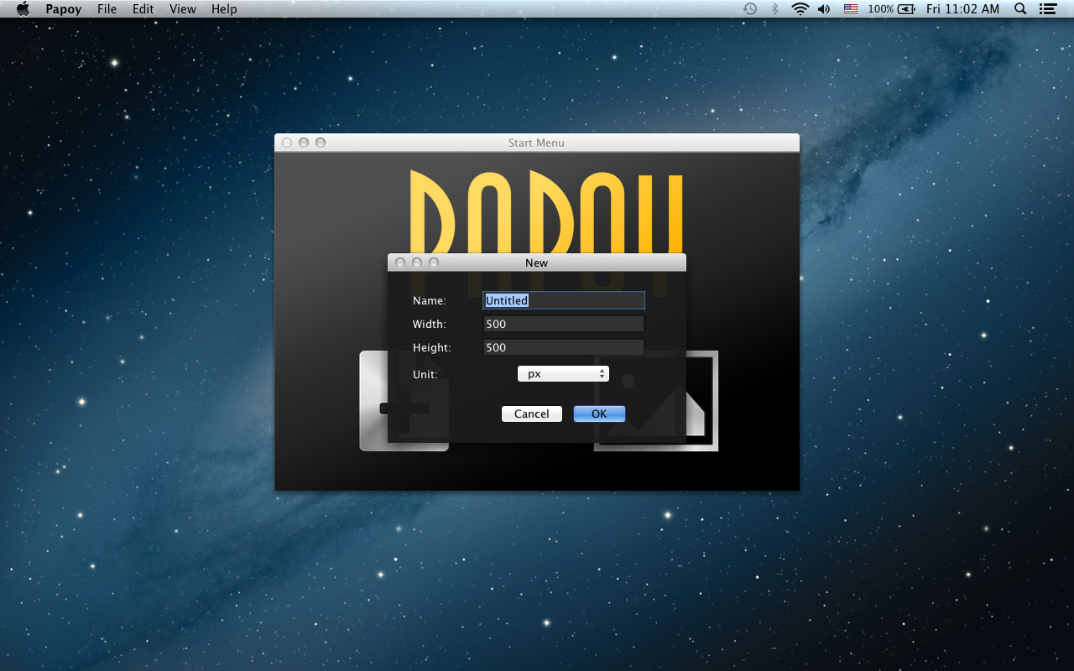

2. When New File is selected, the user will be prompt on the file setting for the new svg.

1. Name: The name for this new svg
2. Width: The width for the svg.
3. Height: The height for the svg.
4. Unit: The units for the width and height.

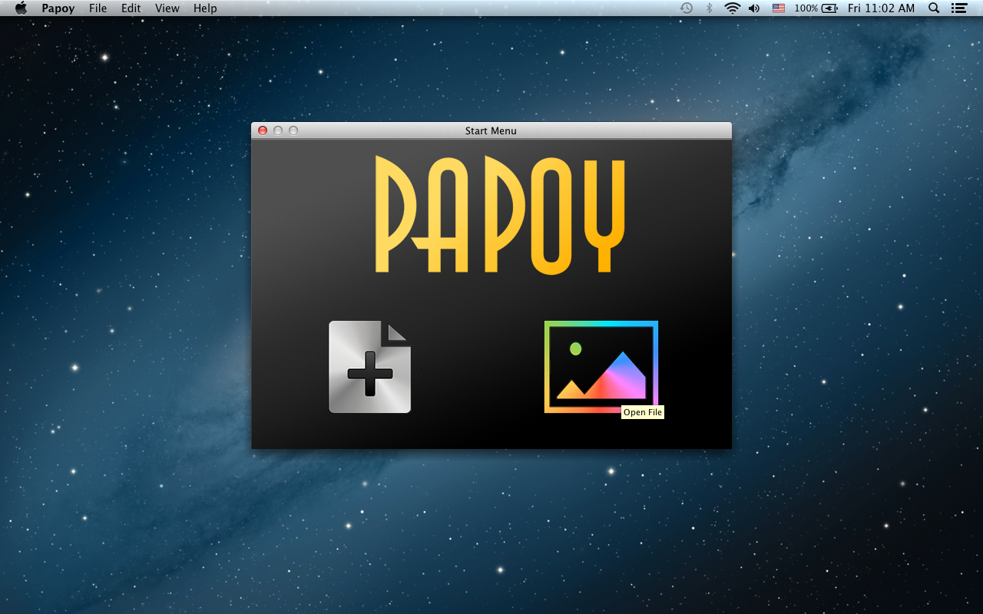

Open Existing Svg

3. To open an existing svg from your local machine using Papoy, select on the Open File icon which will be highlighted when you hover it.

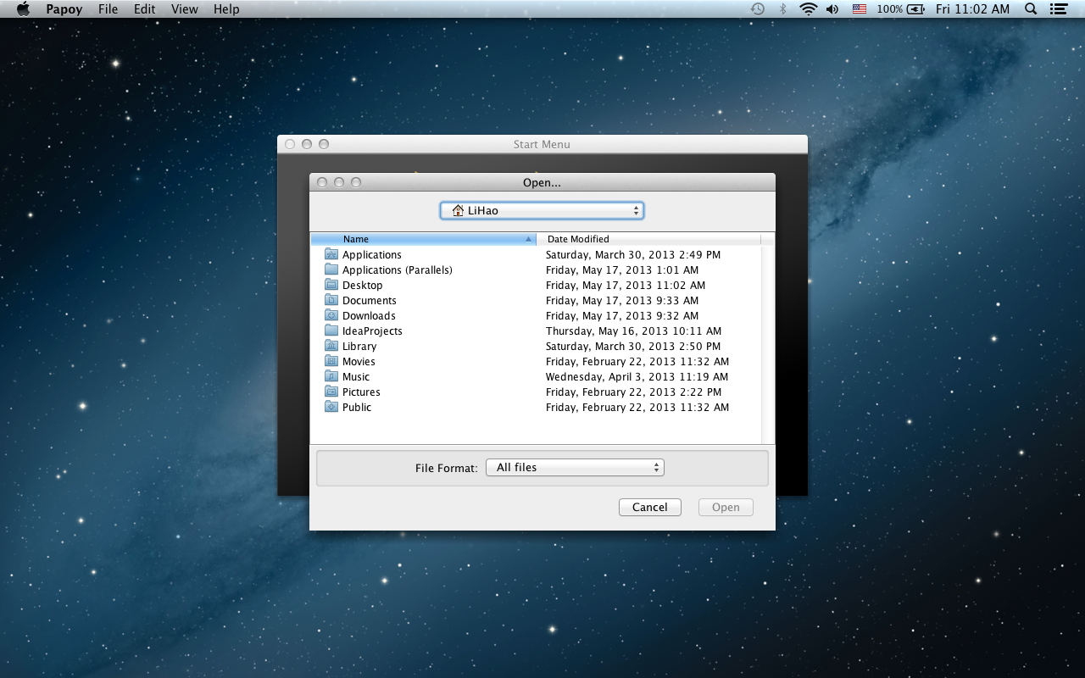

4. Select the svg file you want to open. Only allows you to select file extension of .svg/.xml

# Drawing Kit

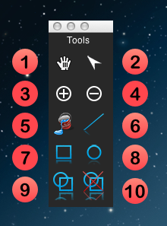

1. Hand Cursor

- Select on Hand Cursor to pan on current svg.

2. Select Cursor

- Select on Select Cursor to select on svg element(s) on current svg. Click on individual svg element to select only 1 svg element, or drag to select multiple svg elements.

3. Zoom In

- Select on Zoom In to zoom in on all opened svg.

4. Zoom Out

- Select on Zoom Out to zoom out on all opened svg.

5. Fill Bucket

- Select on Fill Bucket to change the fill of an individual svg element.

6. Line

- Select on Line to draw a line on a svg.

7. Rectangle

- Select on Rectangle to draw a rectangle on a svg.

8. Circle

- Select on Circle to draw a circle on a svg.

9. Group

- Select on Group to group multiple selected svg elements.

10. Ungroup

- Select on Ungroup to ungroup the selected group to multiple individual svg elements.

# Main Frame

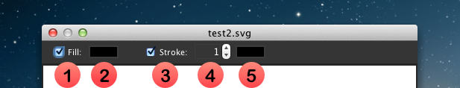

1. Checkbox to allow/disallow Fill attribute.

2. Select the colors for Fill

3. Checkbox to allow/disallow Stroke attribute.

4. Select the stroke width for Stroke

5. Select the colors for Stroke

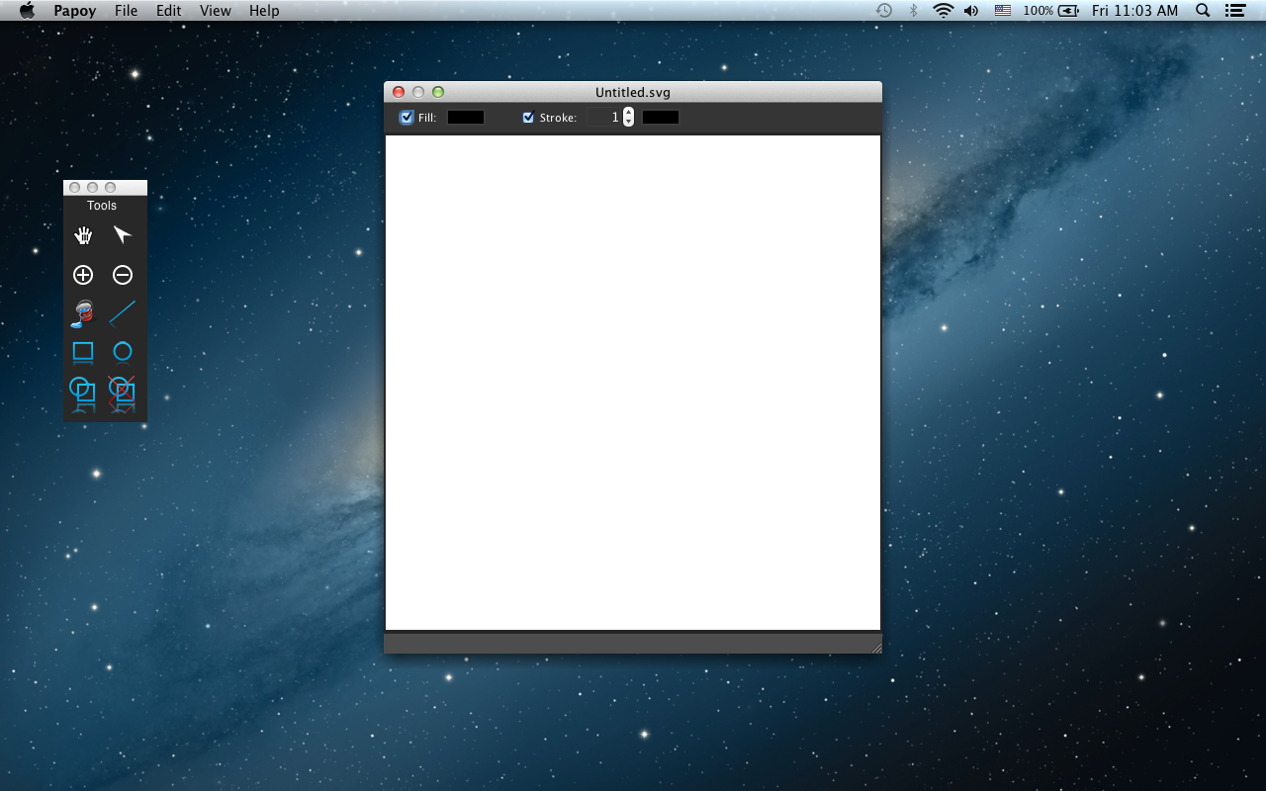

1. This is how the Main Frame would look like if a new svg is created.

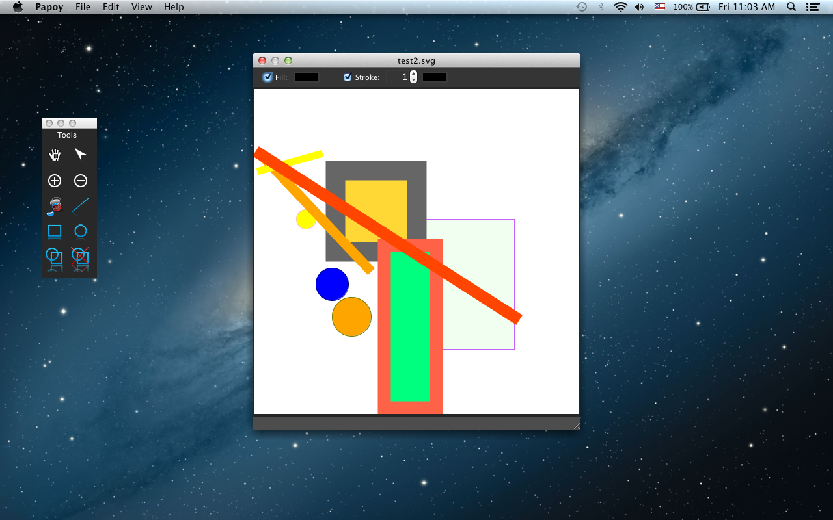

2. This is how the Main Frame would look like if an existing svg is opened. However, Papoy only draws Rectangles, Lines and Circles with basic attribute such as coordination and colors.

Selecting Color Chooser for Fill/Stroke

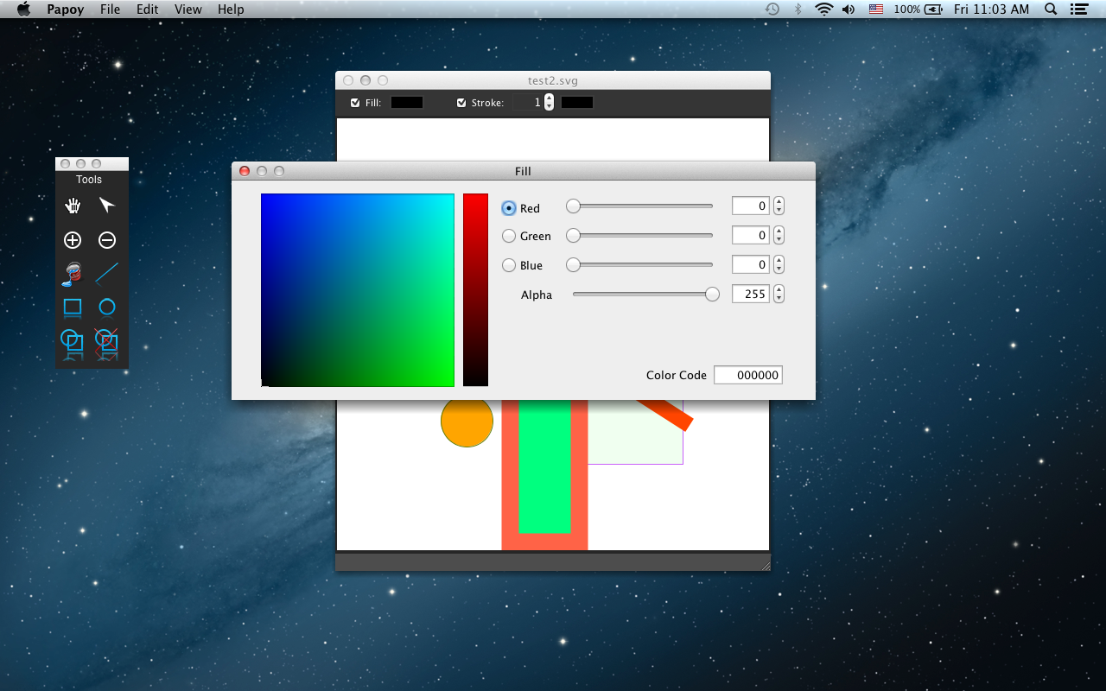

# Menu Bar

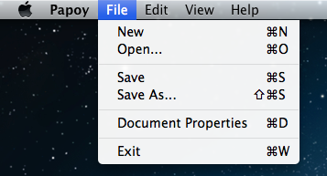

Under the File Menu:

1. New (Command + N for Mac OS / Ctrl + N for Windows)

- Select on New Menu Item to create a new svg.

2. Open… (Command + O for Mac OS / Ctrl + O for Windows)

- Select on Open Menu Item to open an existing svg.

3. Save (Command + S for Mac OS / Ctrl + S for Windows)

- Select on Save Menu Item to save current svg to current directory.

4. Save As… (Command + Shift + S for Mac OS / Ctrl + Shift + S for Windows)

- Select on Save As… Menu Item to save current svg file to a new directory.

5. Document Properties (Command + D for Mac OS / Ctrl + D for Windows)

- Select on Document Properties Menu Item to modify the document properties of current svg.

6. Exit (Command + W for Mac OS / Ctrl + W for Windows)

- Select on Exit Menu Item to exit from Papoy.

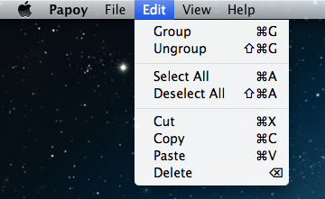

Under the Edit Menu:

1. Group (Command + G for Mac OS / Ctrl + G for Windows)

- Select on Group Menu Item to group multiple svg elements in current svg.

2. Ungroup (Command + Shift + G for Mac OS / Ctrl + Shift + G for Windows)

- Select on Ungroup Menu Item to ungroup svg elements in current svg.

3. Select All (Command + A for Mac OS / Ctrl + A for Windows)

- Select on Select All Menu Item to select all svg elements in current svg.

4. Deselect All (Command + Shift + A for Mac OS / Ctrl + Shift + A for Windows)

- Select on Deselect All Menu Item to deselect all selected svg elements in current svg.

5. Cut (Command + X for Mac OS / Ctrl + X for Windows)

- Select on Cut Menu Item to perform a cut function for svg elements in current svg.

6. Copy (Command + C for Mac OS / Ctrl + C for Windows)

- Select on Copy Menu Item to perform a copy function for svg elements in current svg.

7. Paste (Command + V for Mac OS / Ctrl + V for Windows)

- Select on Paste Menu Item to perform a paste function for svg elements in current svg.

8. Delete (Delete for Mac OS / Backspace for Windows)

- Select on Delete Menu Item to delete selected svg elements in current svg.

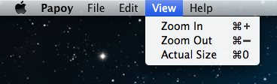

Under the View Menu:

1. Zoom In (Command + ‘+’ for Mac OS / Ctrl + ‘+’ for Windows)

- Select on Zoom In Menu Item to zoom in on all opened svg.

2. Zoom Out (Command + ‘-’ for Mac OS / Ctrl + ‘-’ for Windows)

- Select on Zoom Out Menu Item to zoom out on all opened svg.

3. Actual Size (Command + 0 for Mac OS / Ctrl + 0 for Windows)

- Select on Actual Size Menu Item to revert all view of all opened svg to the actual scale.

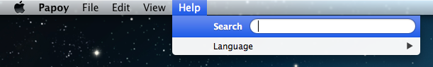

Under the Help Menu:

1. Language

- To change the language for Papoy to other available languages.